**Exploratory Data Analysis (EDA)**

EDA is a phenomenon under data analysis used for gaining a better understanding of data aspects like:

* main features of data
* variables and relationships that hold between them
* Identifying which variables are important for our problem

We shall look at various exploratory data analysis methods like:

* Reading dataset
* Analyzing the data
* Checking for the duplicates
* Missing Values Calculation
* Exploratory Data Analysis
  + Univariate Analysis
  + Bivariate Analysis
  + Multivariate Analysis

**Preprocessing and Data Engineering:**

When referring to data preparation and cleaning, preprocessing is done before raw data is entered into an analytical tool or machine learning model. Missing value handling, feature scaling, categorical variable encoding, and outlier removal are all part of it. To improve the performance and interpretability of the model, it is important to make sure the data is in the right format. Data-driven jobs are more successful overall when preprocessing is used to reduce noise, standardize data, and optimize it for effective analysis.

The practical application of ideas, techniques, and technology for gathering, storing, analyzing, and organizing massive amounts of data is known as data engineering. It includes building reliable data architectures, constructing data pipelines, and putting in place mechanisms that make information flow easier. Data engineers ensure data quality, dependability, and accessibility while building the infrastructure needed to support data-driven applications. Data engineering is a fundamental component of the larger data science and analytics ecosystem because it helps firms extract meaningful insights from their data.

**Step 1: Importing Required Libraries**

|  |
| --- |
| # importting Libraries  **import** pandas as pd  **import** numpy as np  **import** matplotlib.pyplot as plt  **import** seaborn as sns  **import** warnings as wr  wr.filterwarnings('ignore') |

Understanding and experimenting with our data using libraries is the first step in utilizing Python for machine learning. The dataset can be accessed via this link.

Import all of the libraries needed for our investigation, including those for data loading, statistical analysis, visualizations, univariate and bivariate analysis, etc.

**Step 2: Reading Dataset**

|  |
| --- |
| # loading and reading dataset  df **=** pd.read_csv("winequality-red.csv")  print(df.head()) |

**Output:**

fixed acidity volatile acidity citric acid residual sugar chlorides \  
0 7.4 0.70 0.00 1.9 0.076   
1 7.8 0.88 0.00 2.6 0.098   
2 7.8 0.76 0.04 2.3 0.092   
3 11.2 0.28 0.56 1.9 0.075   
4 7.4 0.70 0.00 1.9 0.076   
 free sulfur dioxide total sulfur dioxide density pH sulphates \  
0 11.0 34.0 0.9978 3.51 0.56   
1 25.0 67.0 0.9968 3.20 0.68   
2 15.0 54.0 0.9970 3.26 0.65   
3 17.0 60.0 0.9980 3.16 0.58   
4 11.0 34.0 0.9978 3.51 0.56   
 alcohol quality   
0 9.4 5   
1 9.8 5   
2 9.8 5   
3 9.8 6   
4 9.4 5

**Step 3: Analyzing the Data**

Gaining general knowledge about the data—including its values, kinds, number of rows and columns, and missing values—is the primary objective of data understanding.

shape: shape will show how many features (columns) and observations (rows) there are in the dataset.

|  |
| --- |
| # shape of the data  df.shape |

**Output:**

(1599, 12)

info() facilitates comprehension of the data type and related information, such as the quantity of records in each column, whether the data is null or not, the type of data, and the dataset’s memory use.

|  |
| --- |
| #data information  df.info() |

**Output:**

<class 'pandas.core.frame.DataFrame'>  
RangeIndex: 1599 entries, 0 to 1598  
Data columns (total 12 columns):  
 # Column Non-Null Count Dtype   
--- ------ -------------- -----   
 0 fixed acidity 1599 non-null float64  
 1 volatile acidity 1599 non-null float64  
 2 citric acid 1599 non-null float64  
 3 residual sugar 1599 non-null float64  
 4 chlorides 1599 non-null float64  
 5 free sulfur dioxide 1599 non-null float64  
 6 total sulfur dioxide 1599 non-null float64  
 7 density 1599 non-null float64  
 8 pH 1599 non-null float64  
 9 sulphates 1599 non-null float64  
 10 alcohol 1599 non-null float64  
 11 quality 1599 non-null int64   
dtypes: float64(11), int64(1)  
memory usage: 150.0 KB

**Description of the data**

|  |
| --- |
| # describing the data  df.describe() |

**Output:**

fixed acidity volatile acidity citric acid residual sugar \  
count 1599.000000 1599.000000 1599.000000 1599.000000   
mean 8.319637 0.527821 0.270976 2.538806   
std 1.741096 0.179060 0.194801 1.409928   
min 4.600000 0.120000 0.000000 0.900000   
25% 7.100000 0.390000 0.090000 1.900000   
50% 7.900000 0.520000 0.260000 2.200000   
75% 9.200000 0.640000 0.420000 2.600000   
max 15.900000 1.580000 1.000000 15.500000   
 chlorides free sulfur dioxide total sulfur dioxide density \  
count 1599.000000 1599.000000 1599.000000 1599.000000   
mean 0.087467 15.874922 46.467792 0.996747   
std 0.047065 10.460157 32.895324 0.001887   
min 0.012000 1.000000 6.000000 0.990070   
25% 0.070000 7.000000 22.000000 0.995600   
50% 0.079000 14.000000 38.000000 0.996750   
75% 0.090000 21.000000 62.000000 0.997835   
max 0.611000 72.000000 289.000000 1.003690   
 pH sulphates alcohol   
count 1599.000000 1599.000000 1599.000000   
mean 3.311113 0.658149 10.422983   
std 0.154386 0.169507 1.065668   
min 2.740000 0.330000 8.400000   
25% 3.210000 0.550000 9.500000   
50% 3.310000 0.620000 10.200000   
75% 3.400000 0.730000 11.100000   
max 4.010000 2.000000 14.900000

The DataFrame “df” is statistically summarized by the code df.describe(), which gives the count, mean, standard deviation, minimum, and quartiles for each numerical column. The dataset’s central tendencies and spread are briefly summarized.

**Checking Columns**

|  |
| --- |
| #column to list  df.columns.tolist() |

**Output:**

['fixed acidity',  
 'volatile acidity',  
 'citric acid',  
 'residual sugar',  
 'chlorides',  
 'free sulfur dioxide',  
 'total sulfur dioxide',  
 'density',  
 'pH',  
 'sulphates',  
 'alcohol',  
 'quality']

The code df.columns.tolist() converts the column names of the DataFrame ‘df’ into a Python list, providing a convenient way to access and manipulate column names.

**Checking Missing Values**

|  |
| --- |
| # check for missing values:  df.isnull().sum() |

**Output:**

fixed acidity 0  
volatile acidity 0  
citric acid 0  
residual sugar 0  
chlorides 0  
free sulfur dioxide 0  
total sulfur dioxide 0  
density 0  
pH 0  
sulphates 0  
alcohol 0  
quality 0  
dtype: int64

The code df.isnull().sum() checks for missing values in each column of the DataFrame ‘df’ and returns the sum of null values for each column

**Checking for the duplicate values**

|  |
| --- |
| #checking duplicate values  df.nunique() |

**Output:**

fixed acidity 96  
volatile acidity 143  
citric acid 80  
residual sugar 91  
chlorides 153  
free sulfur dioxide 60  
total sulfur dioxide 144  
density 436  
pH 89  
sulphates 96  
alcohol 65  
quality 6  
dtype: int64

The function df.nunique() determines how many unique values there are in each column of the DataFrame “df,” offering information about the variety of data that makes up each feature.

**Exploratory Data Analysis**

EDA is a vital step in the data analysis process that entails visually and statistically analyzing datasets to find patterns, trends, and insights.

The principal goals of exploratory data analysis (EDA) are to detect anomalies in the dataset and develop recommendations for additional investigation, thereby guaranteeing a thorough comprehension of the subtleties of the data.

To obtain a comprehensive understanding of the data, analysts use a variety of EDA approaches, including summary statistics, correlation analysis, and data visualization using tools like box plots, scatter plots, and histograms.

EDA provides insightful information that helps with hypothesis creation and decision-making by improving knowledge of data distribution, variable correlations, and anomalies. When all is said and done, the efficacy of data-driven projects is enhanced by EDA’s capacity to identify trends and anomalies.

**Step 4: Univariate Analysis**

In Univariate analysis, plotting the right charts can help us better understand the data, which is why data visualization is so important. Matplotlib and Seaborn libraries are used in this post to visualize our data.

Basic charts can be created with Matplotlib, a Python 2D charting package.

Seaborn is a Python library that leverages short code segments to generate and customize statistical charts from Pandas and Numpy, based on the Matplotlib framework.

For both numerical and categorical data, univariate analysis is an option.

In this example, we are going to plot different types of plots like swarmplots, violinplots, and countplots for univariate analysis.

|  |
| --- |
| # Assuming 'df' is your DataFrame  quality_counts **=** df['quality'].value_counts()    # Using Matplotlib to create a count plot  plt.figure(figsize**=**(8, 6))  plt.bar(quality_counts.index, quality_counts, color**=**'darpink')  plt.title('Count Plot of Quality')  plt.xlabel('Quality')  plt.ylabel('Count')  plt.show() |

**Output:**

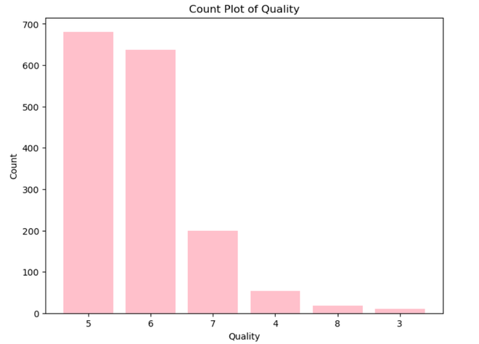

Here , this count plot graph shows the count of the wine with its quality rate.

**Kernel Density Plots**

|  |
| --- |
| # Set Seaborn style  sns.set_style("darkgrid")    # Identify numerical columns  numerical_columns **=** df.select_dtypes(include**=**["int64", "float64"]).columns    # Plot distribution of each numerical feature  plt.figure(figsize**=**(14, len(numerical_columns) **\*** 3))  **for** idx, feature **in** enumerate(numerical_columns, 1):      plt.subplot(len(numerical_columns), 2, idx)      sns.histplot(df[feature], kde**=**True)      plt.title(f"{feature} | Skewness: {round(df[feature].skew(), 2)}")    # Adjust layout and show plots  plt.tight_layout()  plt.show() |

**Output:**

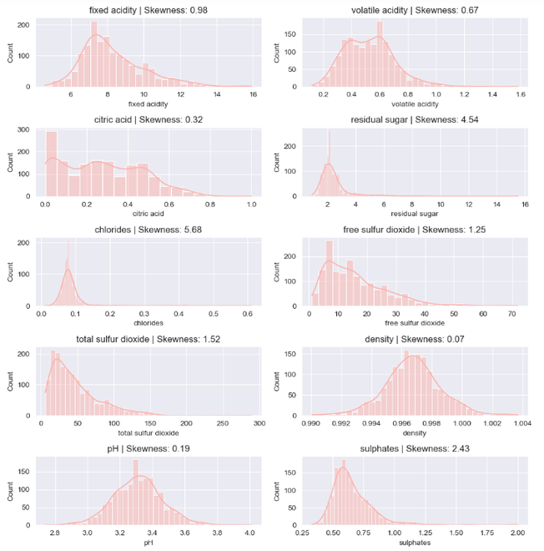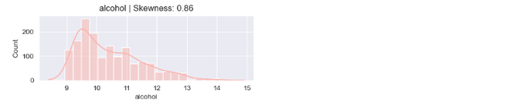

Here, in the kernel density plot is about the skewness of the of the corresponding feature. The features in this dataset that have skewness are exactly 0 depicts the symmetrical distribution and the plots with skewness 1 or above 1 is positively or right skewd distribution. In right skewd or positively skewed distribution if the tail is more on the right side, that indicates extremely high values.

**Step 5: Bivariate Analysis**

When doing a bivariate analysis, two variables are examined simultaneously in order to look for patterns, dependencies, or interactions between them. Understanding how changes in one variable may correspond to changes in another requires the use of this statistical method.

Bivariate analysis allows for a thorough comprehension of the interdependence between two variables within a dataset by revealing information on the type and intensity of associations.

Let’s plot a pair plot for the data.

**Pair Plot**

|  |
| --- |
| # Set the color palette  sns.set_palette("Pastel1")    # Assuming 'df' is your DataFrame  plt.figure(figsize**=**(10, 6))    # Using Seaborn to create a pair plot with the specified color palette  sns.pairplot(df)    plt.suptitle('Pair Plot for DataFrame')  plt.show() |

**Output:**

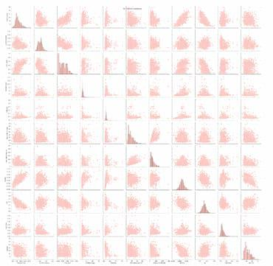

* If the plot is diagonal , histograms of kernel density plots , is shows the distribution of the individual variables.
* If the scatter plot is in the lower triangle, it displays the relationship between the pairs of the variables.
* If the scatter plots above and below the diagonal are mirror images, indicating symmetry.
* If the histogram plots are more centered, it represents the locations of peaks.
* Skewness is depicted by observing whether the histogram is symmetrical or skewed to the left or right.

**Box Plot**

|  |
| --- |
| #plotting box plot between alcohol and quality  sns.boxplot(x**=**'quality', y**=**'alcohol', data**=**df) |

**Output:**

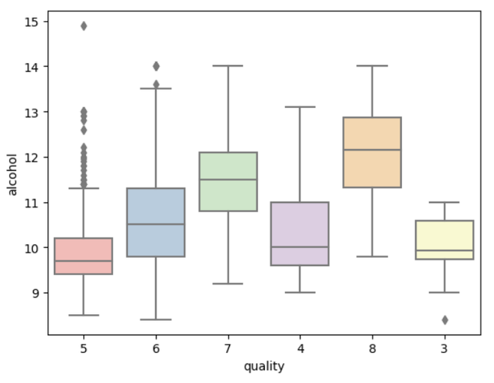

For interpreting the box plot,

* Box represents the IQR. Longer the box, greater the variability.
* The median line in the box indicates central tendency.
* Whiskers extend from box to the smallest and largest values within a specified range.
* Individual points beyond the whiskers represents outliers.
* A compact box indicates low variability while a stretched box indicates higher variability.

**Step 6: Multivariate Analysis**

Interactions between three or more variables in a dataset are simultaneously analyzed and interpreted in multivariate analysis.

In order to provide a comprehensive understanding of the collective behavior of several variables, it seeks to reveal intricate patterns, relationships, and interactions between them.

Multivariate analysis examines correlations and dependencies between numerous variables by using sophisticated statistical techniques such factor analysis, principal component analysis, and multivariate regression.

Multivariate analysis, which is widely applied in domains such as biology, economics, and marketing, enables thorough insights and helps decision-makers make well-informed judgments based on complex relationships found in multidimensional datasets.

Here, we are going to show the multivariate analysis using a correlation matrix plot.

**Correlation Matrix**

|  |
| --- |
| # Assuming 'df' is your DataFrame  plt.figure(figsize**=**(15, 10))    # Using Seaborn to create a heatmap  sns.heatmap(df.corr(), annot**=**True, fmt**=**'.2f', cmap**=**'Pastel2', linewidths**=**2)    plt.title('Correlation Heatmap')  plt.show() |

**Output:**

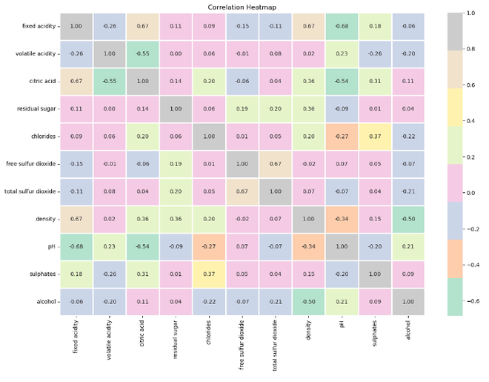

For interpreting a correlation matrix plot,

* Values close to +1 indicates strong positive correlation, -1 indicates a strong negative correlation and 0 indicates suggests no linear correlation.
* Darker colors signify strong correlation, while light colors represents weaker correlations.
* Positive correlation variable move in same directions. As one increases, the other also increases.
* Negative correlation variable move in opposite directions. An increase in one variable is associated with a decrease in the other.

**Conclusion**

In summary, the Python-based exploratory data analysis (EDA) of the wine dataset has yielded important new information about the properties of the wine samples. We investigated correlations between variables, identified outliers, and obtained a knowledge of the distribution of important features using statistical summaries and visualizations. The quantitative and qualitative features of the dataset were analyzed in detail through the use of various plots, including pair, box, and histogram plots. Finding patterns, trends, and possible topics for more research was made easier by this EDA method. Furthermore, the analysis demonstrated the ability to visualize and analyze complicated datasets using Python tools such as Matplotlib, Seaborn, and Pandas. The results provide a thorough grasp of the wine dataset and lay the groundwork for more in-depth studies and modeling.